



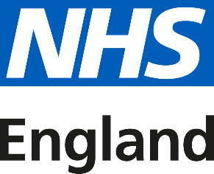
Step into the NHS: Information Analyst
NHSE Analytics Career Progression
Related Websites

What’s next after school?
If you've been working towards A levels (or the equivalent), you could apply for a degree in statistical analysis or another relevant subject. Check university prospectuses well in advance for details of courses and entry requirements.
Alternatively, there are sometimes informatics apprenticeships in the NHS.
Job and apprenticeship vacancies in the NHS can be found on the NHS Jobs website www.jobs.nhs.uk.

You can also find apprenticeships on the Gov.uk website www.gov.uk/apply-apprenticeship
You'll need a good range of GCSEs (or the equivalent) to demonstrate basic education, and should consider taking A levels (or the equivalent) at 6th form or college.
You might also consider obtaining your European Computer Driving Licence to demonstrate knowledge of Microsoft Office and take courses to become familiar with software used within the sector.
There are sometimes informatics apprenticeships in the NHS.
- maths knowledge
- creative skills to design & deliver
- analytical thinking skills
- to be thorough and pay attention to detail
- excellent verbal communication skills
- the ability to think clearly using logic and reasoning
- persistence and determination
- the ability to work on your own
- concentration skills
- to have a thorough understanding of computer systems and applications
- feel comfortable engaging with clinical and non-clinical workforce and subject matter experts

Does this sound like you?

You work at your local NHS hospital, analysing data to check national healthcare standards are being met in your area.
Today, you're benchmarking patient waiting times, gathering facts and statistics from internal databases and national reports. You use a statistical computer program to read the data, so you can easily see patterns and possible data-collection errors. Then you write up patient-waiting-time trends in a report, using data visualisation and storytelling narrative, explaining how your hospital compares with national healthcare standards.
You discover patients are waiting much longer for some treatments than others, and email senior members of staff to make them aware of this trend. You enjoy using your skills to make sure healthcare standards are met, transforming data into actionable insights, and like working regular 9-5 hours.

A day as an information analyst

